**Client-Side App Rubric** <https://github.com/denisecase/pbl-lifeline-links>

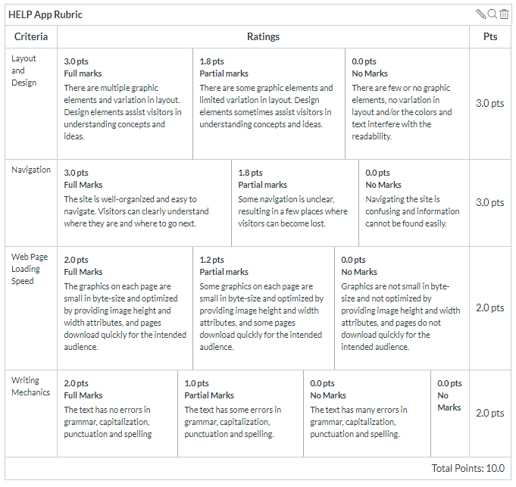

**Team reviewed:**

Group 02-07

**Link to the web site:**

<https://prudhvi15.github.io/help-app-07/>

**Layout and Design**

Score: 3

Comments:

-unique layout,

-We like the one-page layout because there isn’t a lot of information to put on other pages.

-color scheme works well.

-Pictures could be a little bigger because it is hard to understand what they are.

-the typography for the headers are really attention-grabbing.

**Navigation**

Score: 3

Comments:

-once again, the one page is really easy to navigate.

-we like that it is stuck on the left side.

**Loading Speed:**

Score: 2

Comments:

-loads well, limited pictures.

**Writing Mechanics:**

Score: 2

Comments:

-no spelling errors.

**General remarks:**

-We really enjoy the layout of the website.

-The design choices are really strong and make for a really easy-to-read and user friendly site.

**Review performed by:**

Group 4

**Date and time performed:**

12/5

1:02pm